March 2023:

Helena McMonagle measured fish lengths from photos taken from large fish collected on R/V Cook with the MOCNESS-1 (1 meter squared mouth opening when towed at ~45°)

Image J measurements collected with either straight lines or, when fish were bent, line segments tool in Image J (see below for example)

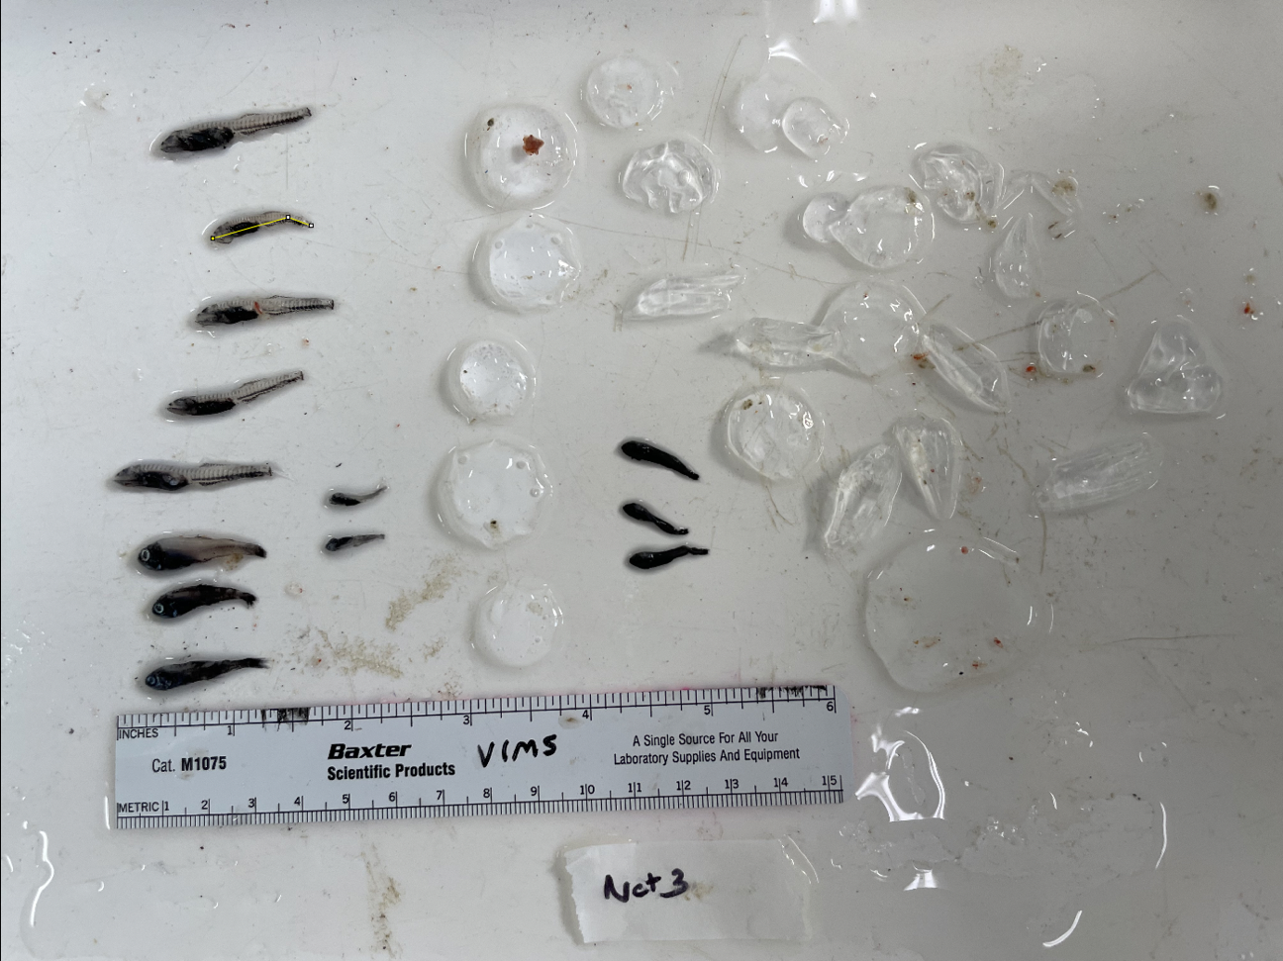

If there was a net with no fish photos, we can assume none were caught in that net.

All but 1 single fish (evident in zooscan from rest of catch) was pulled out and photographed in these net photos of fish and other large zooplankton, so process of picking out and photographing fish was very thorough.

Fish family was recorded.

Fish were measured from top right to bottom left, reading from top to bottom of each column and then moving to the right when one column is completed.

Any fish smaller than 2.0 cm were not considered adults and were not counted (check with others on this)

Standard lengths were recorded as accurately as possible based on knowledge of where vertebrae end on these fish species in relation to caudal fin. Challenging to get total length when caudal fins are damaged, folded over, transparent or damaged.

**Tow 10 (day)**

fish found in nets 2, 3, 4, and one fish in net 10

photo taken, but no fish in net 5, 6 and 9 (only large zooplankton)

**Tow 11 (night)**

fish found in nets 2, 3, (and 10 in the next tow, which is a continuation of this tow)

photo taken, but no fish in net 6, 8 and 9 (only large zooplankton)

**Tow 12 (night, continued--treated as continuation of tow 11)**

lots of fish in net 10

**Tow 47 (day)**

fish found in nets 2, 3, 4, 5

skipped measuring the very small fish in net 2 that was unidentifiable on the far right of photo

leptocephalus (and large zooplankton) found in net 6, but not counting fish larvae

photo taken, but no fish in net 6, 7, 8, 9 and 10

used 2.15 as scale for net 5 (took 3 measurements and averaged), because there was no ruler so I took 3 measurements of lab tape width from net 4 photo and used the tape width for scale in net 5 photo

**Tow 48 (night)**

fish found in nets 2, 3, 6, 8, 9, 10

**Tow 89 (day)**

fish found in nets 2, 3, 4, 5, 6

ask about the unknown in net 3 tow 90 (see below) and net 3 in net 89. Are these “unknown” fish the same species or at least family? Are they melamphids perhaps? Try to nail this down so we have fewer unknowns. These may also be the same as other unknowns in previous tows above. There’s a much larger melamphid (bigscale i.e. ridgehead, I think) in net 4 tow 90

Net 4 in tow 89 doesn’t have the ruler shown, so I used the white tap width for scale. Calculated this width (from the photo of net 3 that had a ruler) of tape to be 2.219, 2.080, and 2.191 cm, which averages to 2.163 cm. So, used 2.163 cm as width of tape for setting the scale for the photo of the net 4 catch.

**Tow 90 (night)**

fish found in nets 2, 3, 4, 6, 7, 10